**Database Design Best Practices**

* Determine the purpose of your database.
* Find and organize the information required.
* Divide the information into tables.
* Turn information items into columns.
* Consistency (of data types, naming standards etc.)
* Specify primary keys and Set up the table relationships
* Apply the normalization rules to reduce data redundancy.
* Performance: when and how to apply indexes, how to write efficient queries etc.
* When and how to use different DB objects like views, procedures, functions, triggers.

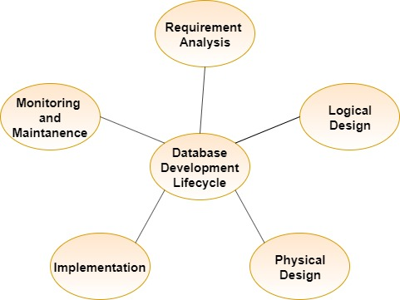

**(DDLC)**

**Data Model:**

A data model refers to the logical structure of the database and data flow between different data elements involved in it. It defines how data is connected to each other and how they are processed and stored. Data models helps in the visual representation what data is required and what format is to be used for different business processes.

**Process:**

Data modeling is the process of creating a data model for the data to be stored in a Database. The process of data modeling can be done in three different ways such as

* **Conceptual Model** - It is the concise description of business process/ requirements of the system. The conceptual model is developed independently of any software tools. It rely more on real life situations and scenarios rather than technical concepts.
* **Logical Model** - Logical data models add further information to the conceptual model elements. It defines the structure of the data elements and set the relationships between them.The advantage of the Logical data model is to provide a foundation to form the base for the Physical model.
* **Physical Model** - A Physical Data Model describes the database specific implementation of the data model.

**Attributes, Entity and Relationships:**

An **entity** can be a real-world object, that can be easily identifiable. It is anything in the enterprise that is to be represented in our database which can be a physical thing or simply a fact about the enterprise or an event that happens in the real world.

An **attribute** is a characteristic to define an entity**.** Attributes are help to describe an entity. The association among entities is called **relationship**.

**Table: Product**

|  |  |  |  |
| --- | --- | --- | --- |
| **Product Id** | **Category** | **Product Name** | **Cost (Rs.)** |
| 1. | Health Supplement | Boost | 240 |
| 2. | Personal Care | Himalaya Soap | 54 |

(i.e.) In the above table, Product is an entity and Product Name, Category and Cost are the characteristics (attributes) to describe Product entity.